ANSIBLE

Set up ansible

sudo apt-get install ansible

ansible - -version

cd /etc/ansible/

ls

cat hosts

# Ansible How to Establish ssh connection between server and Node | Devops

Create 3 ec2 linux instances

Keypair

Root code

!#/bin/bash

Sudo su

Yum update -y

Ansible server

Node1

Node2 created

Goto server

Sudo su

wget <https://dl.fedoraproject.org/pub/epel/epel-release-latest-7.noarch.rpm>

yum install git python python-level python-pip openssl ansible -y

Check ansible install or not

vi /etc/ansible/hosts (enter add node1 node 2 private ips in groups)

vi /etc/ansible/ansible.cfg

uncomment remove # for inventory and sudo_user

adduser ansible (#ansible user name) do on node 1, and node 2 also

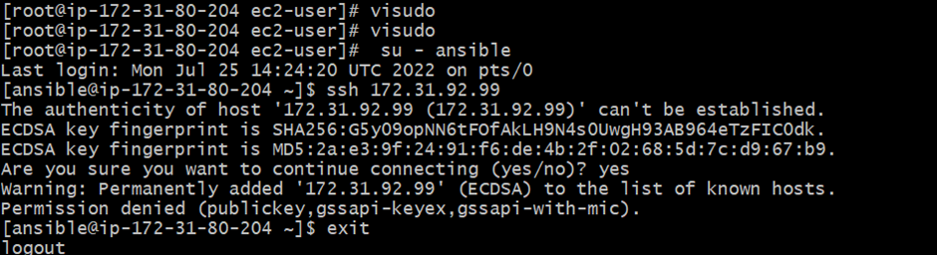

su – ansible

exit

go to root

Visudo

Add oneline ansible ALL=(ALL) NOPASSWD: ALL (same will be done to node 1 and node 2)

save

vi /etc/ssh/sshd_config (same will be done to node 1 and node 2)

remove #

Remove # and add #to last

Now ,

service sshd restart

su – ansible

ssh (pivate ip of node 1) repeat for node2 also create file and check

create files1 2 3

logout

Now without password we need to login so do keygen

Ls -a

Cd .ssh/

Ls

ssh-copy-id [ansible@172.31.90.42 (private](mailto:ansible@172.31.90.42%20%20(private) ip of any node1 or node2)

Same do for another node also

Hosts patterrns

**Playbook**

Go to Server

Vi target.yml

--- #my first- playbook

- hosts: demo

user: ansible

become: yes

connection: ssh

gather_facts: yes

~

ansible-playbook target.yml =========run this cmd

**Another playbook to install httpd on two nodes**

Vi task.yml

--- # myplaybook2

- hosts: demo

user: ansible

become: yes

connection: ssh

tasks:

- name: install HTTPD on centos 7

action: yum name=httpd state=installed

~

Which httpd (check if available remove)

sudo yum remove httpd -y

**Variables in playbook**

Vi variable.yml

--- #my variable file

- hosts: demo

user: ansible

become: yes

connection: ssh

vars:

pkgname: httpd

tasks:

- name: install HTTPD server on centos 7

action: yum name='{{pkgname}}' state=installed

**HANDLERS**

Ls

Remove httpd

sudo yum remove httpd -y (( on two nodes because I will install again

vi handlers

--- # playbook for handlers

- hosts: demo

user: ansible

become: yes

connection: ssh

tasks:

- name: installed httpd server for centos

action: yum name=httpd state=installed

notify: restart httpd

handlers:

- name: restart httpd

action: service name=httpd state=restarted

~

Dry run



Ansible-playbook handlers.yml --check

**Conditions**

Vi condition.yml

--- #conditional playbook

- hosts: demo

user: ansible

become: yes

connection: ssh

tasks:

- name: install apache server for debian family

command: apt-get -y install apache2

when: ansible_os_family == "Debian"

- name: install apache server for redhat family

command: yum -y install httpd

when: ansible_os_family == "RedHat"

l

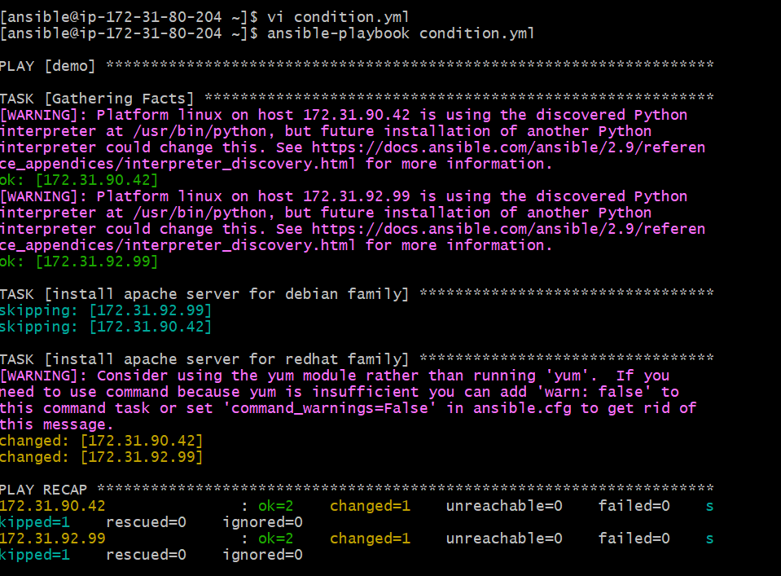

**ROLES**

STEP1: INSTALL TREE

sudo yum install tree -y

tree

Step 2: mak a directory

mkdir -p playbook/roles/webserver/tasks

cd playbook/

touch roles/webserver/tasks/main.yml

ls

Touch master.yml

Tree

vi roles/webserver/tasks/main.yml

- name: install apache on RedHat

yum: pkg=httpd state=latest

Vi master.yml

--- # master playbook for webservers

- hosts: demo

user: ansible

become: yes

connection: ssh

roles:

- webserver

